Celebal Assignment 5
Week 5 Task :
Q1: What are the key limitations of traditional MapReduce that make Spark a preferred choice for modern big data processing?
The Superstore dataset contains sales transactions across regions, products, and customers. Traditional MapReduce writes intermediate results to disk after every step, making analysis slower. Spark processes data in memory, which significantly speeds up operations such as filtering, grouping, and sales analytics. Spark also provides DataFrames, SQL, machine learning, and streaming support in a single platform.
Q2: Explain how Spark uses In-Memory Computing to speed up iterative machine learning algorithms compared to disk-based systems.
When analyzing the Superstore dataset repeatedly (e.g., calculating sales, profit, and customer trends), Spark can cache the dataset in memory:
df.cache()
This avoids repeatedly reading data from disk and improves performance for iterative analytics and machine learning tasks.
Q3: Write a code snippet to remove all duplicate rows from a DataFrame based on a specific set of columns: user_id and transaction_date.
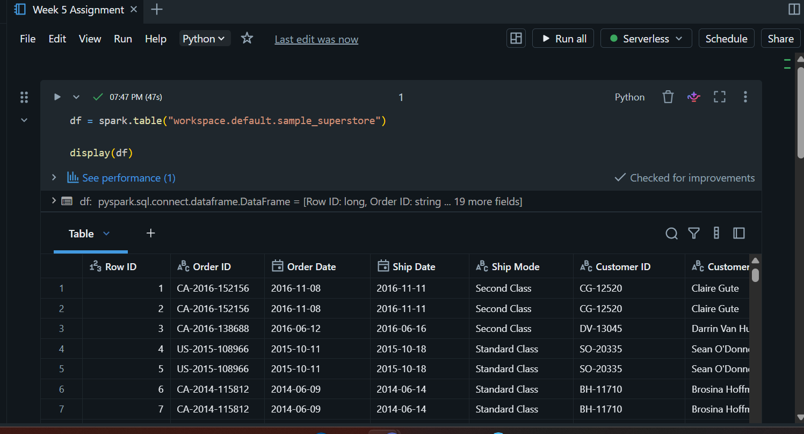
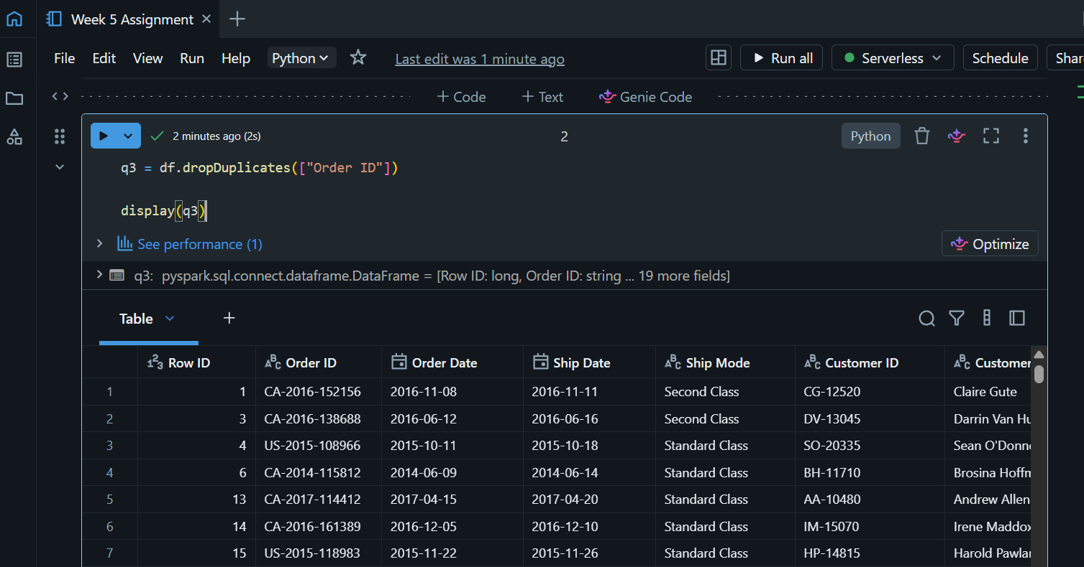

Q4: Given a DataFrame df_sales, write a query to filter for rows where the region is 'West' and then group by product_category to find the average sale_amount.
This identifies how different product categories perform in the West region by calculating their average sales.
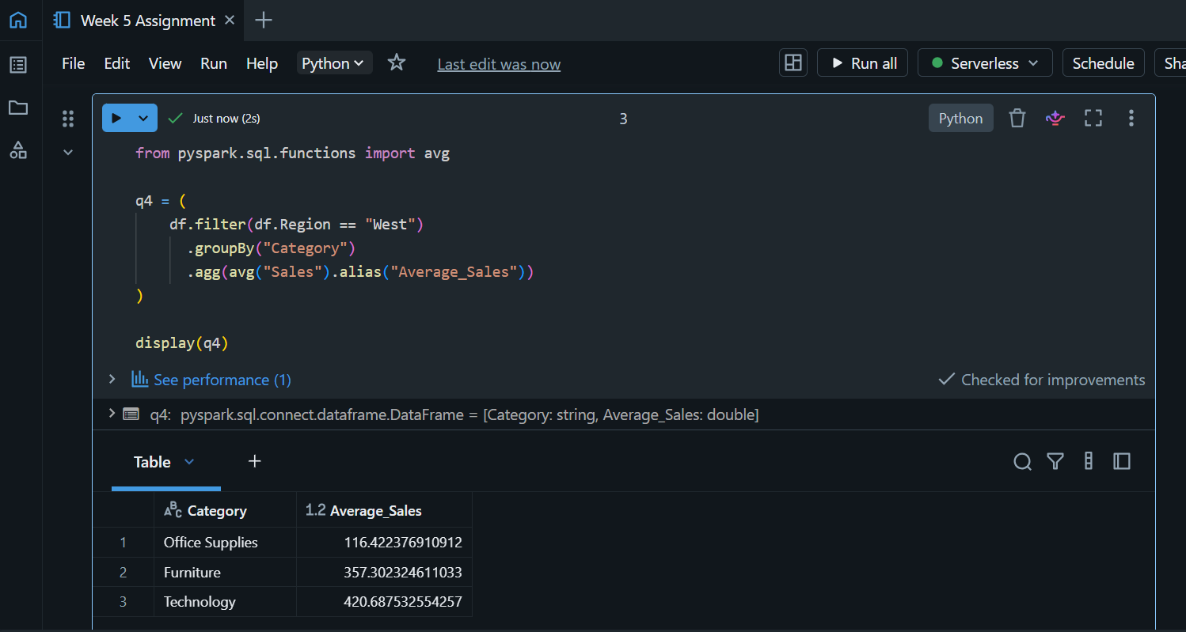

Q5: What is the difference between .na.drop() and .na.fill()? Provide a code example of filling null values in a status column with the string 'Unknown'.
Method | Purpose

.na.drop() | Removes rows containing null values

.na.fill() | Replaces null values with a specified value
Q6: Write a query to find the total count of records for each city in a DataFrame, but only for cities where the count is greater than 100.
This helps identify high-demand cities that generate significant order volumes.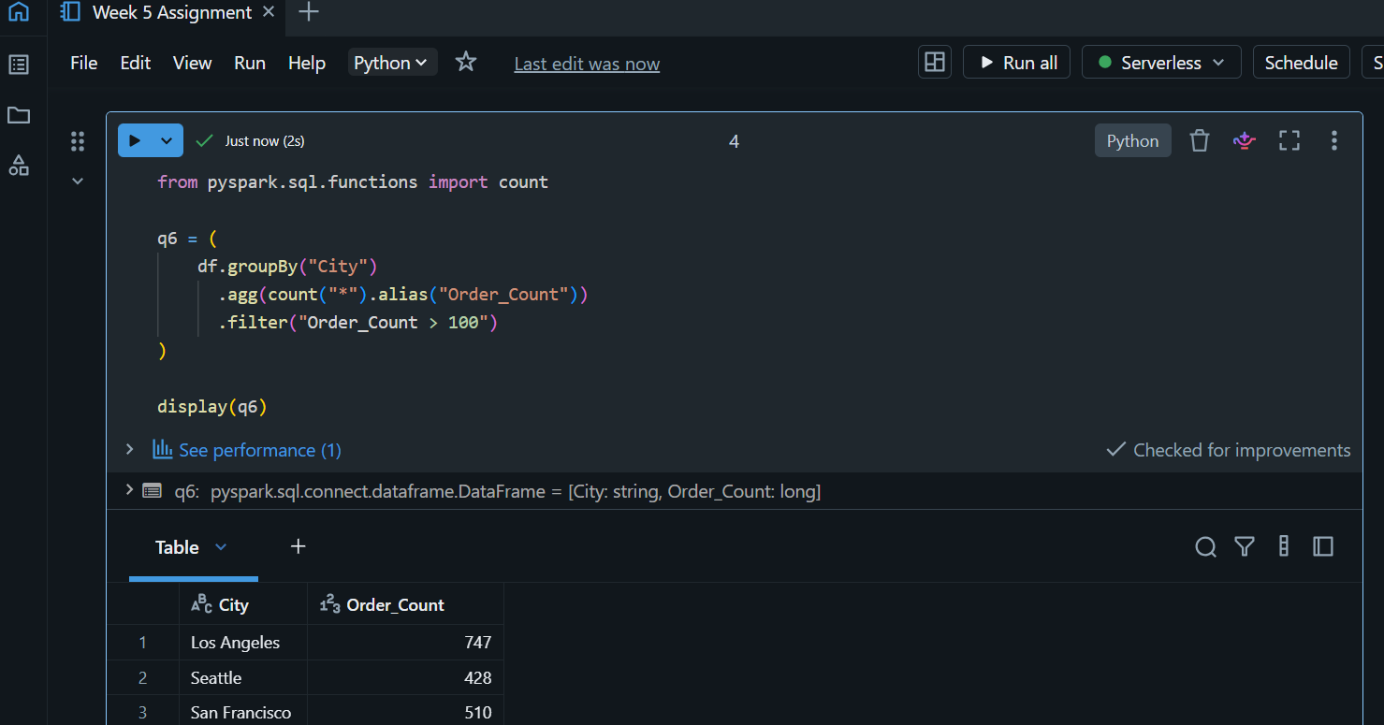

Q7: How does the immutability of Spark DataFrames affect how you perform "data cleaning" steps like dropping columns or renaming them?
Spark DataFrames are immutable. Dropping the Postal Code column creates a new DataFrame while the original dataset remains unchanged.
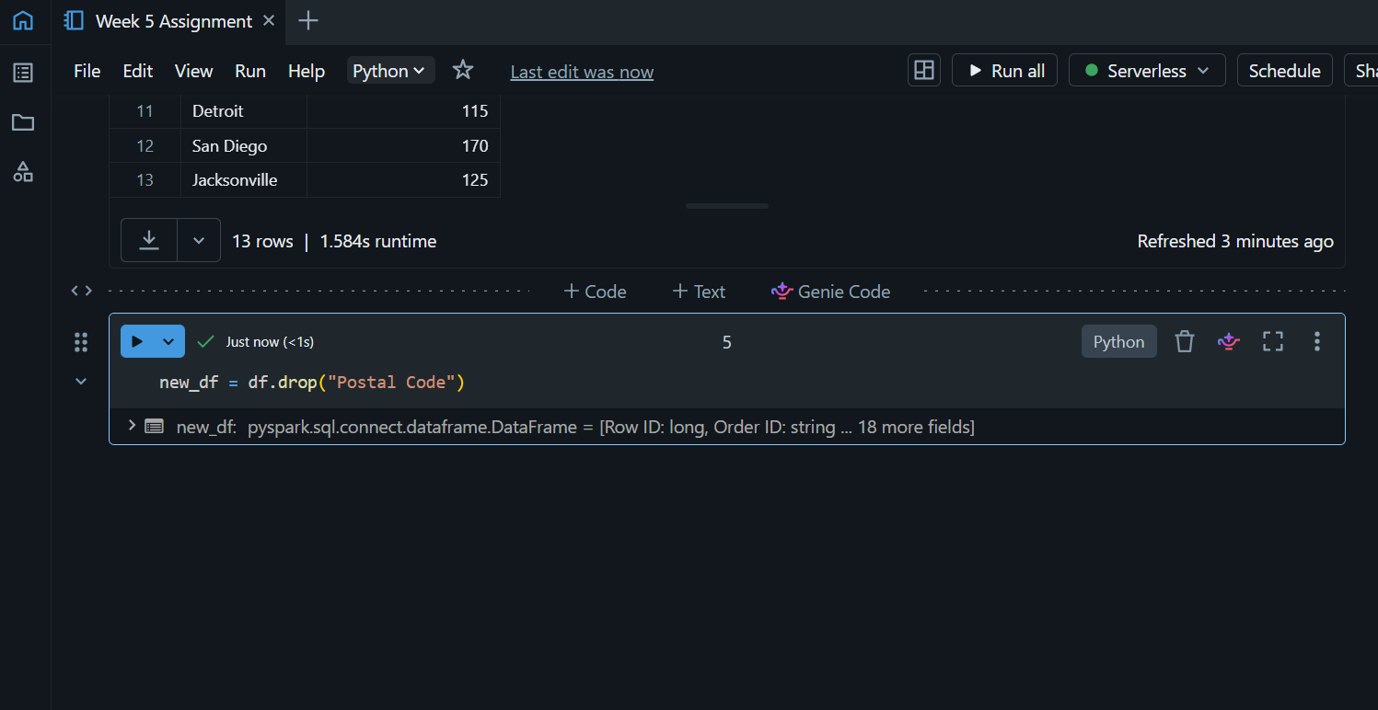
Q8: Write a Spark command to filter a dataset for rows where the age is between 18 and 30 (inclusive) and the subscription is 'Premium'.
The dataset does not contain Age or Subscription.
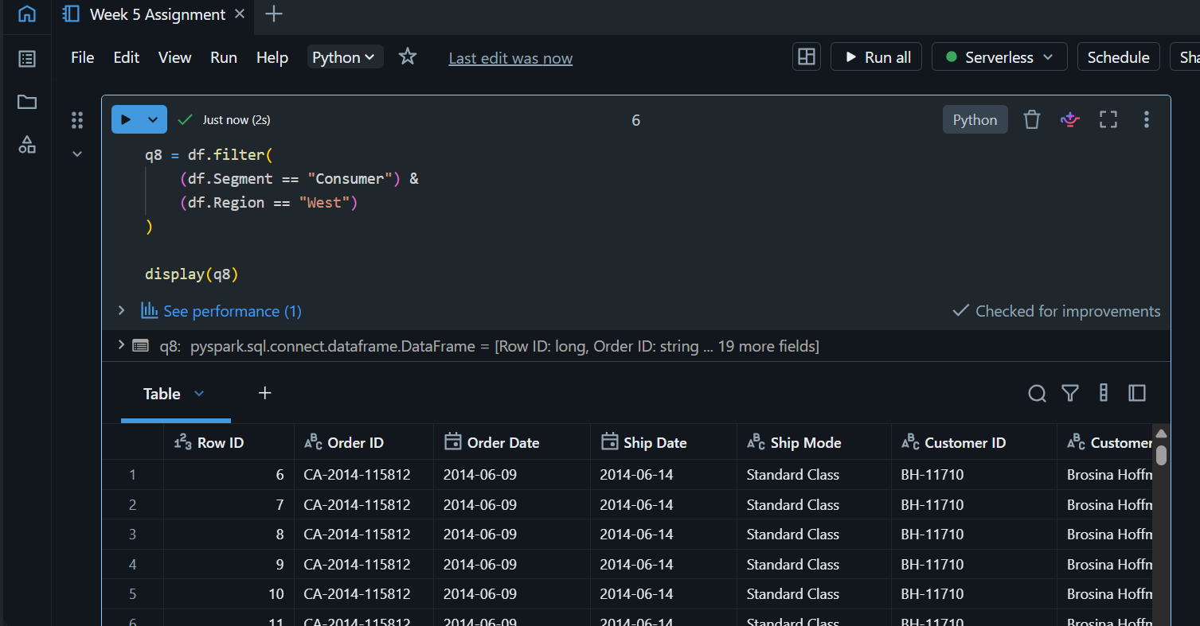
This filters orders belonging to Consumer customers in the West region.
Q9: When cleaning a dataset, why is it often better to handle null values before performing mathematical aggregations like sum() or avg()?
Null values can distort sales and profit calculations. Filling missing values before aggregation ensures accurate totals and averages.
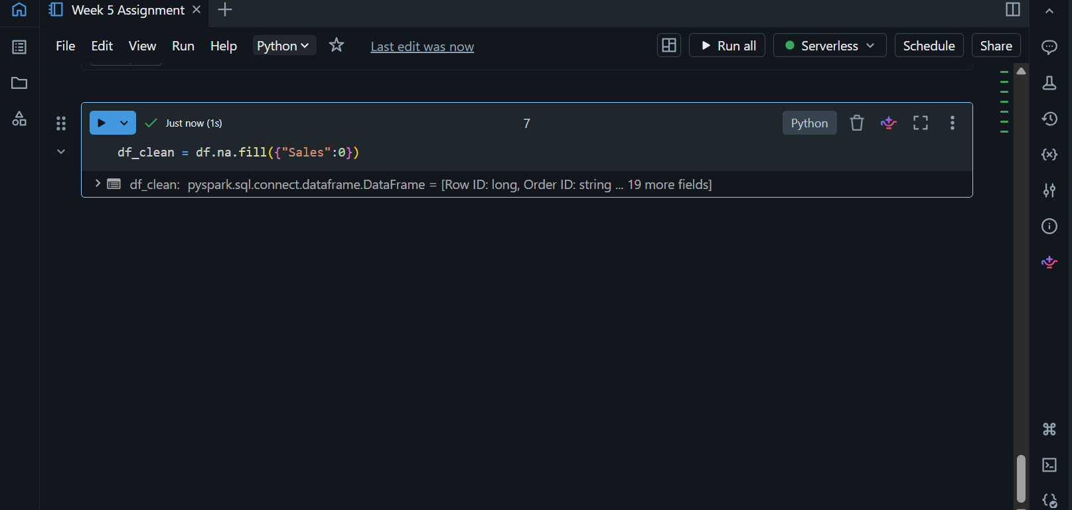

Q10: Write the code to revise a column named raw_timestamp by casting it to a TimestampType and renaming it to event_time.
The Order Date column is converted into a timestamp for advanced time-series analysis.
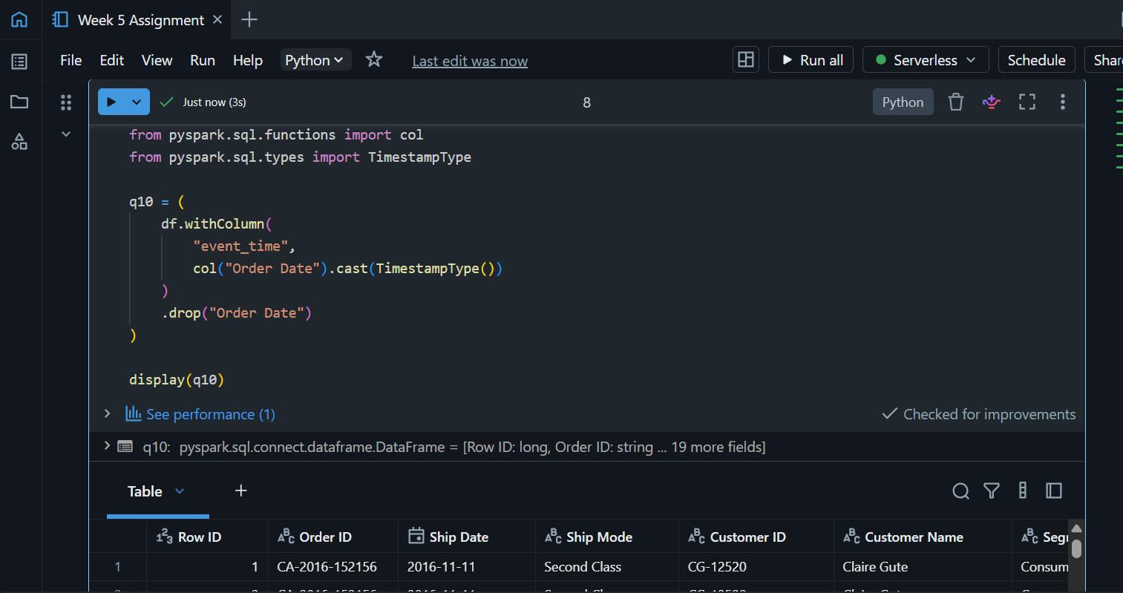
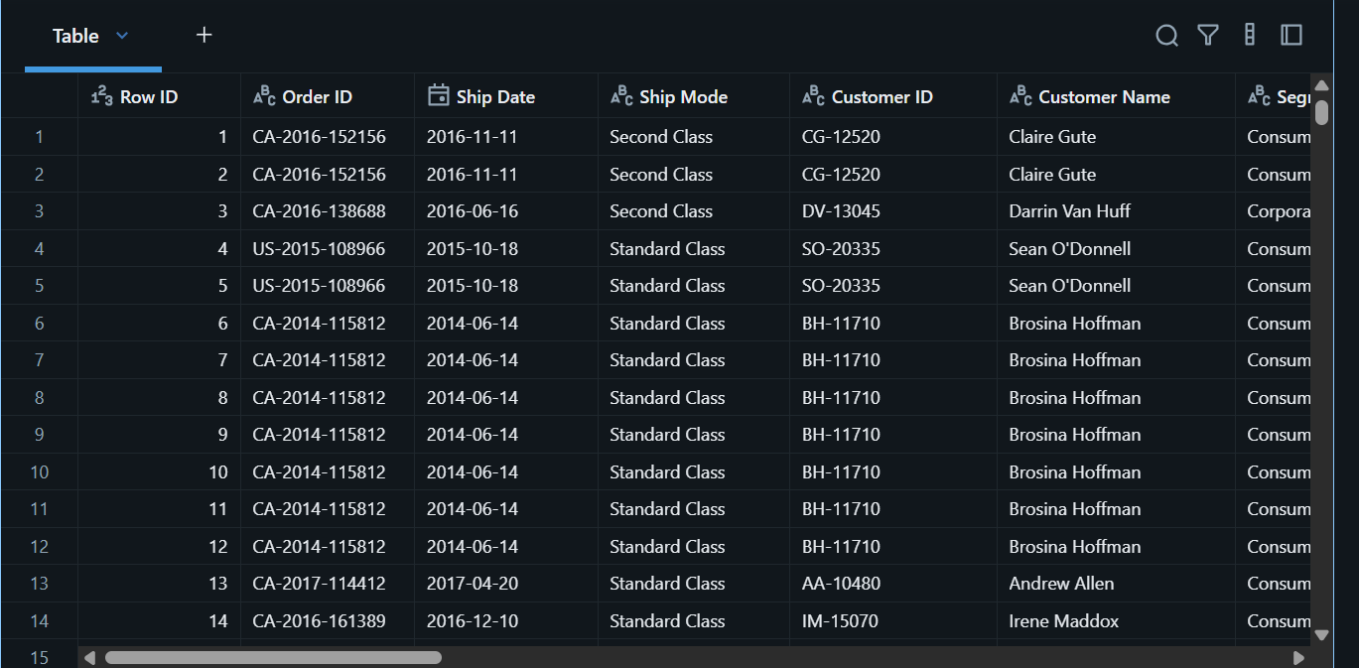
Q11: Explain the "Shuffle" process that occurs during a grouping operation. Why is it considered a wide transformation?
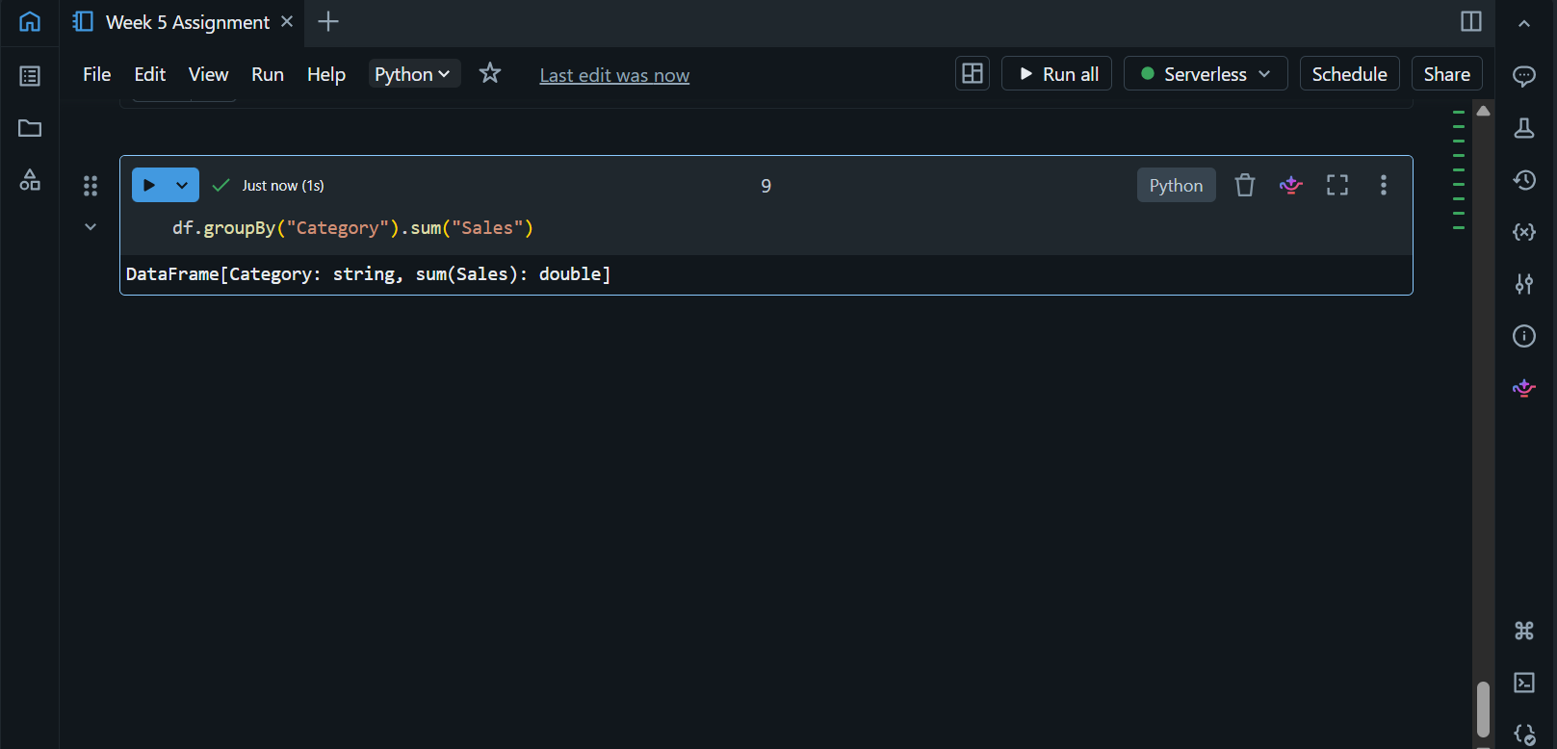
all records belonging to the same category must be brought together across partitions. This data movement is called a shuffle. Since data moves across executors, it is considered a wide transformation and is one of Spark's most expensive operations.

Q12: Write a code snippet that identifies and removes rows where the email column contains null values OR the username is an empty string.

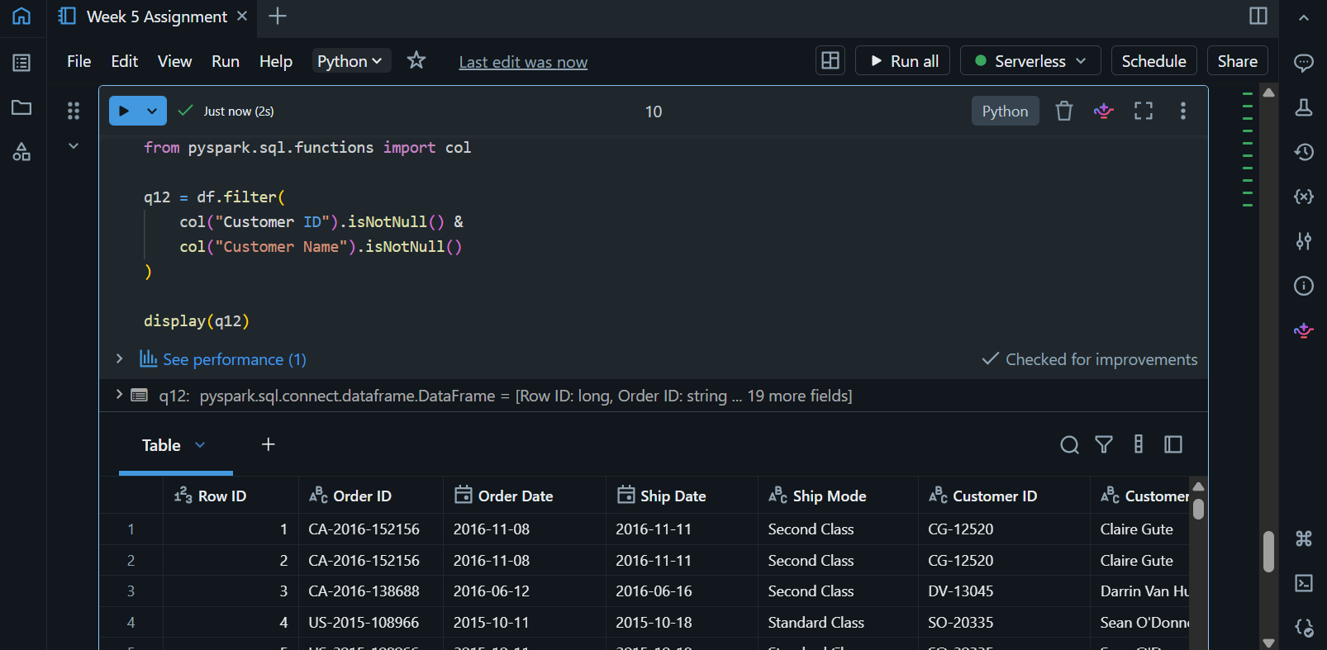

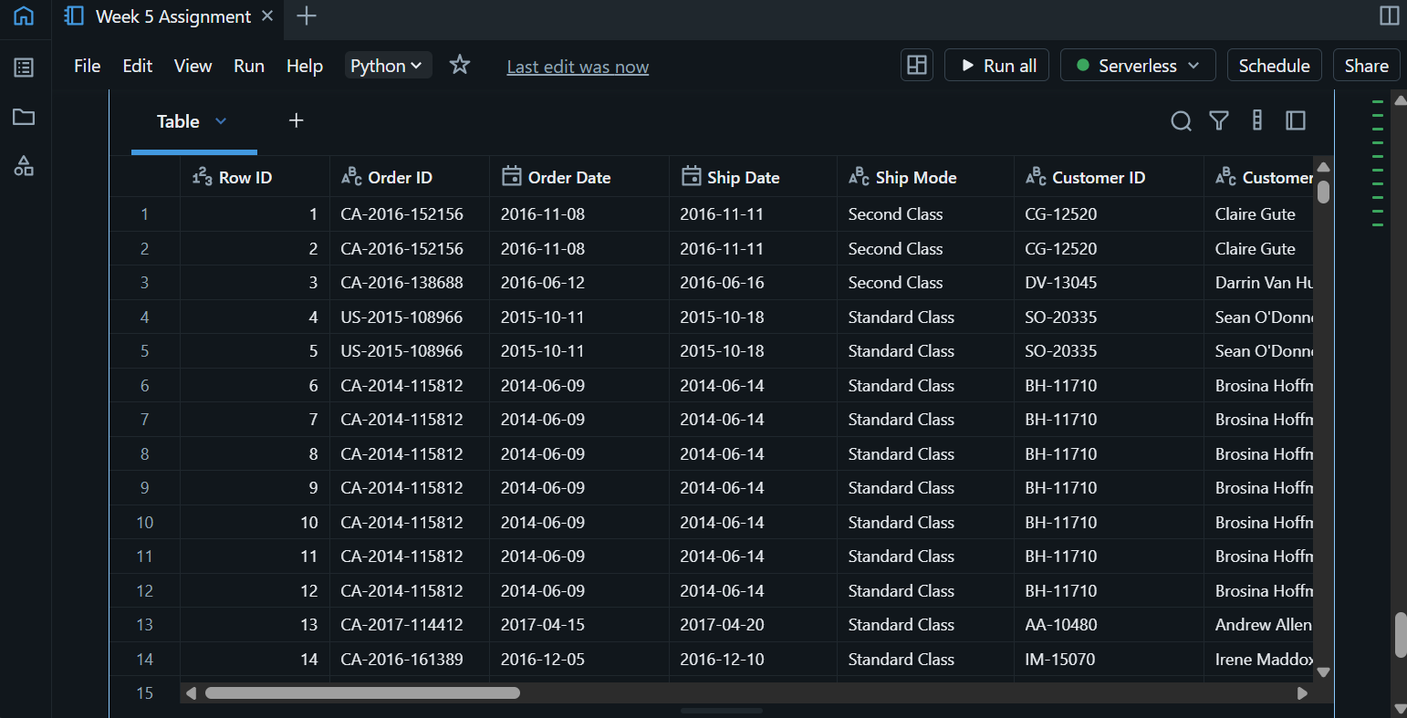

Q13: How do you use the .agg() function to calculate multiple statistics at once, such as the min, max, and mean of the price column?
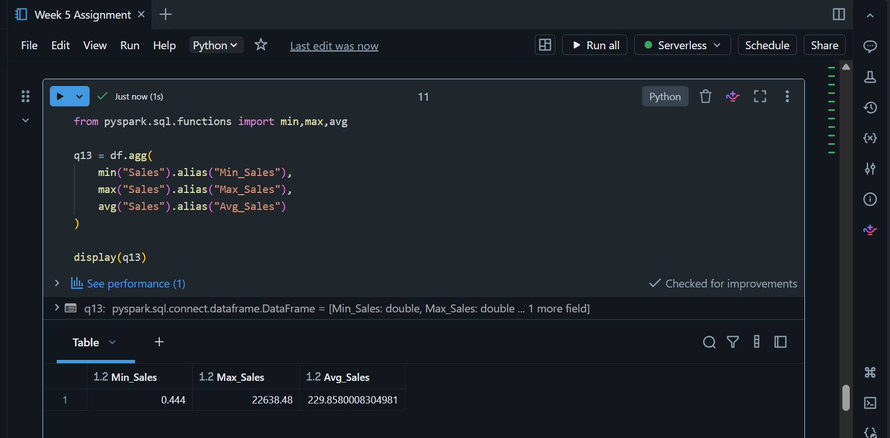
This provides a quick statistical summary of sales performance across all orders.
Q14: In the context of cleaning a dataset, what is the risk of using inferSchema=true when your source data contains messy or inconsistent date formats?
Although the Superstore dataset has clean dates, messy datasets may contain inconsistent formats such as:
2025-01-01
01/01/2025
Jan-01-2025
Using inferSchema=True may cause Spark to infer incorrect data types or convert dates to strings. Explicit schemas are safer for production environments.

Q15: Write a final processing pipeline that:
- Filters out duplicates.
- Fills null prices with 0.
- Groups by store_id to calculate total revenue.

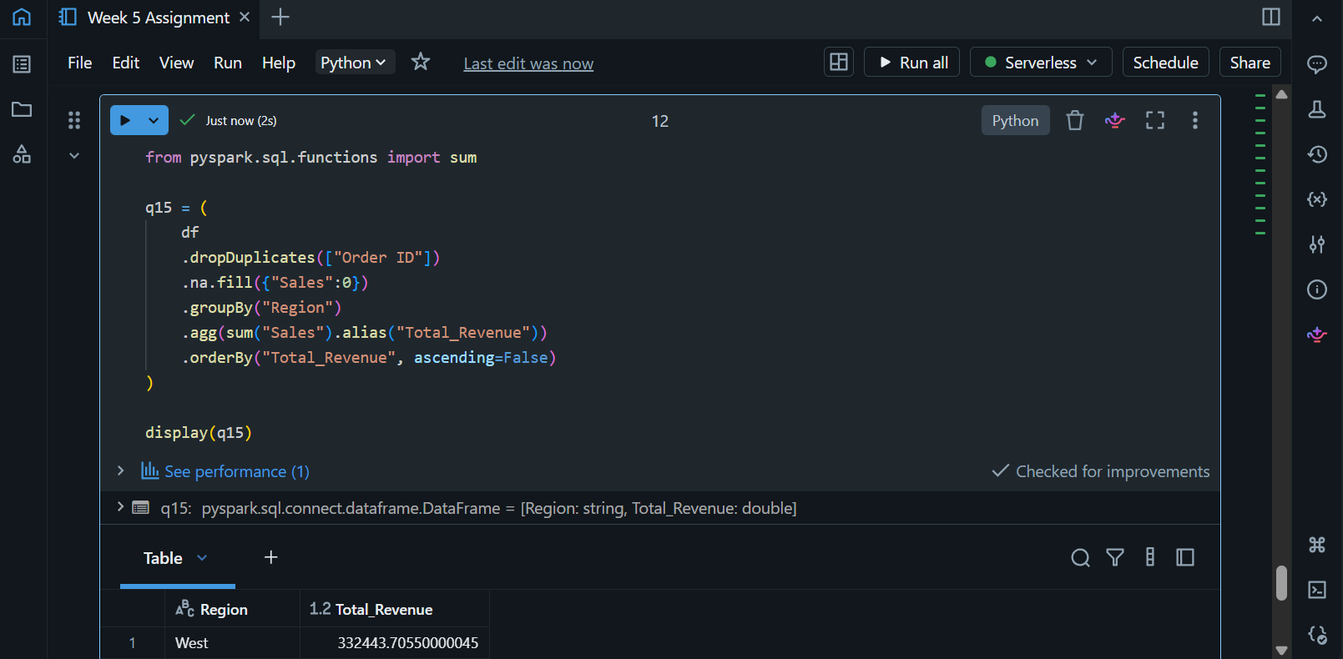
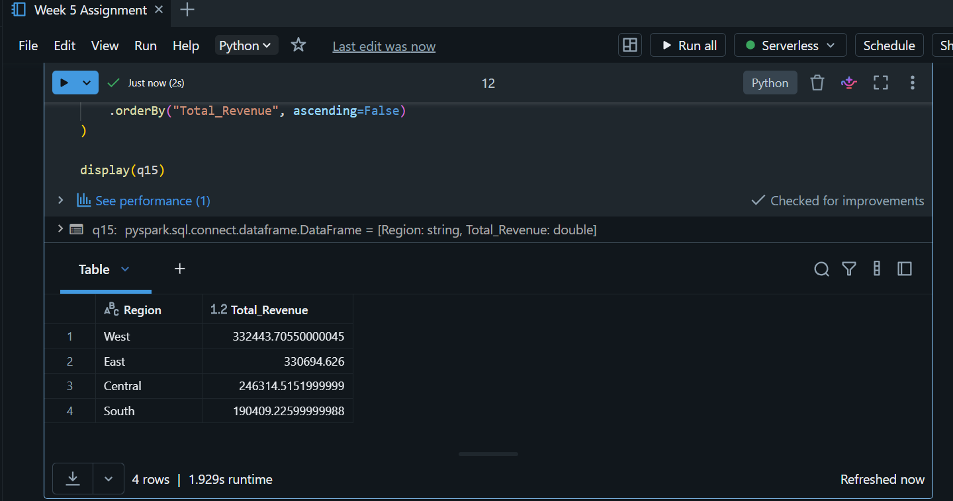

Insight
This pipeline:
Raw Superstore Data
↓
Remove Duplicate Orders
↓
Fill Missing Sales
↓
Group by Region
↓
Calculate Total Revenue
↓
Rank Regions by Revenue

